**SIR SAYYED COLLGE OF ARTS, COMMERCE & SCIENCE LIBRARY**

**USER AWARENESS PROGRAM**

**Date:-09/10/2017**

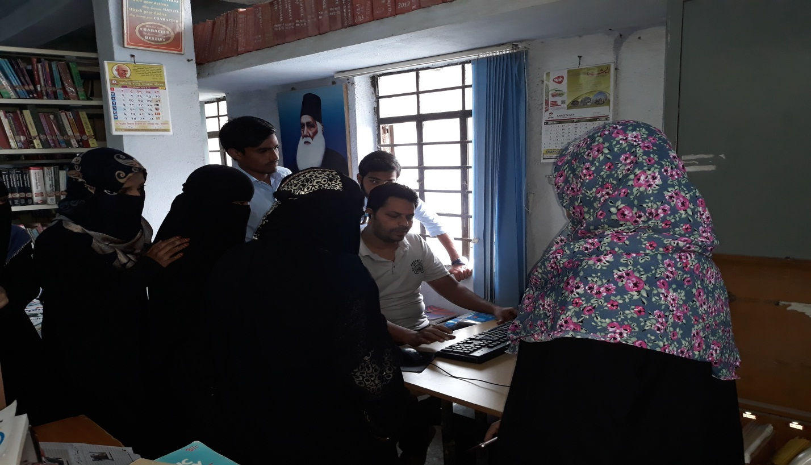

Library Assistant, Mr. Wahaj Ali Khan explains the OPAC and Library facilities

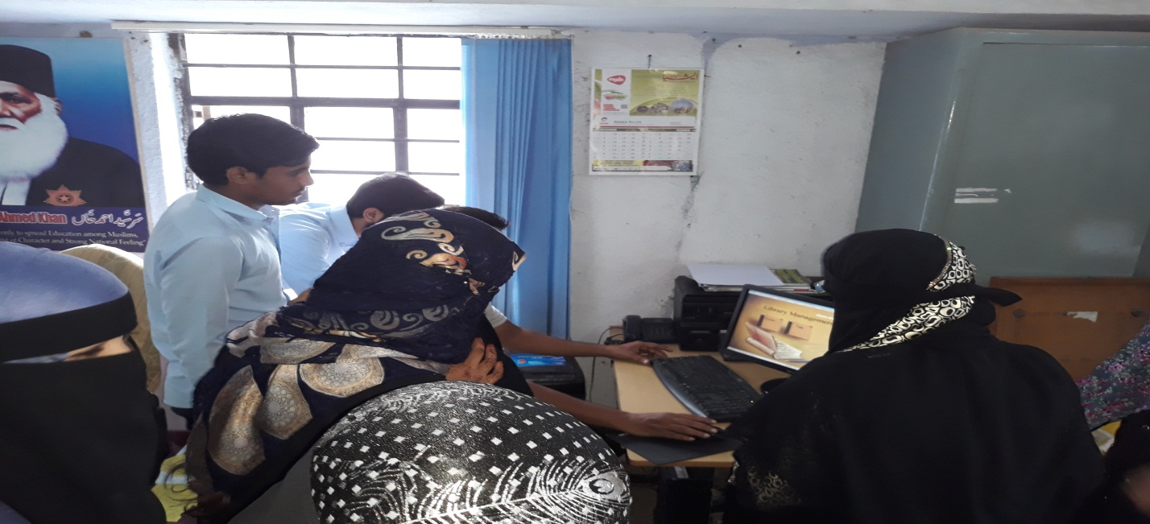

Students handle the software, OPAC

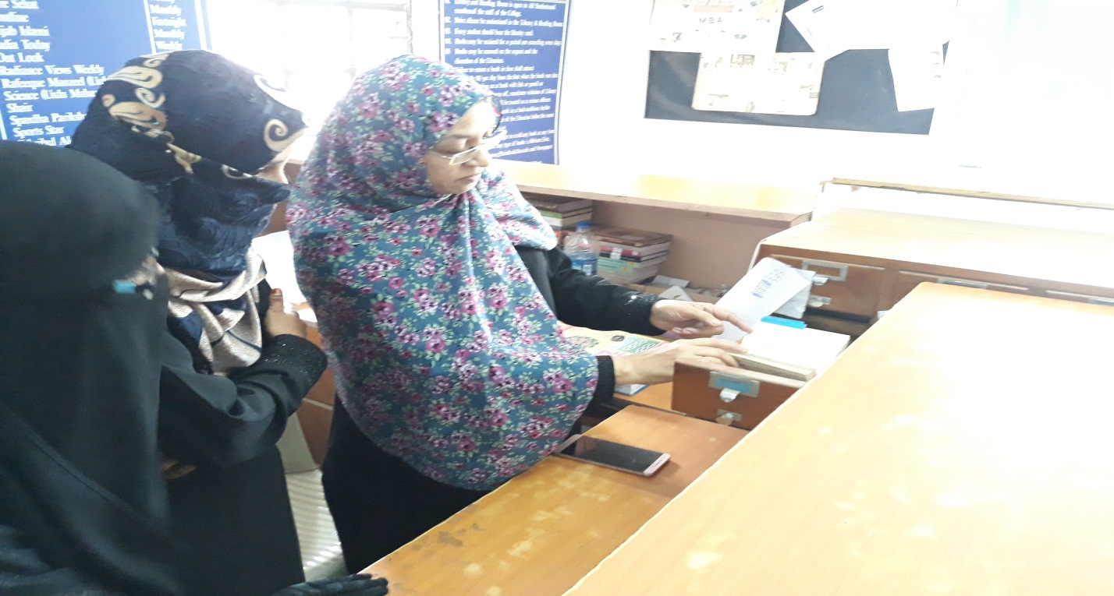

Prof. Maimnat jahan Ara guides the students for searching through Library Catalogue

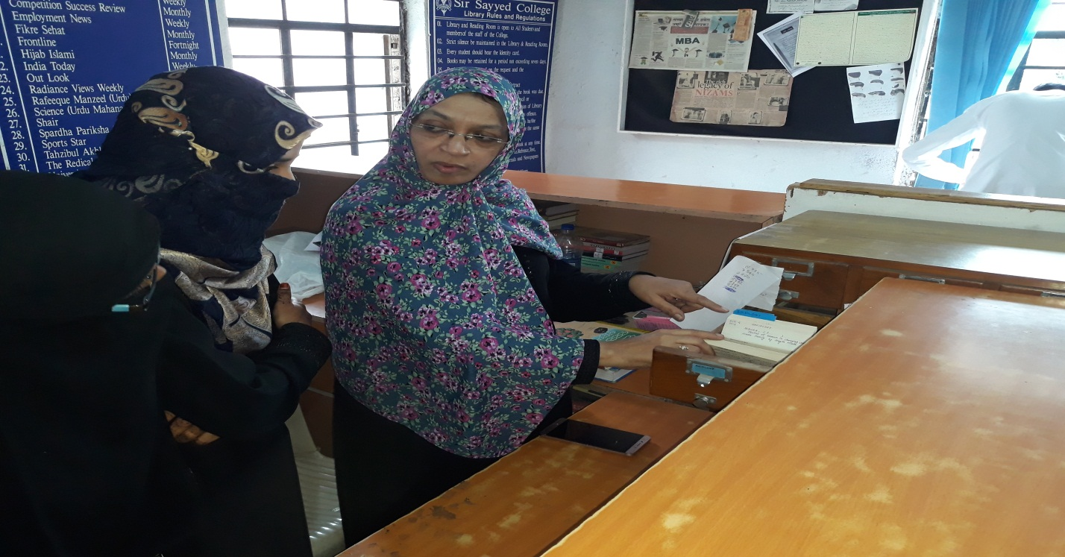

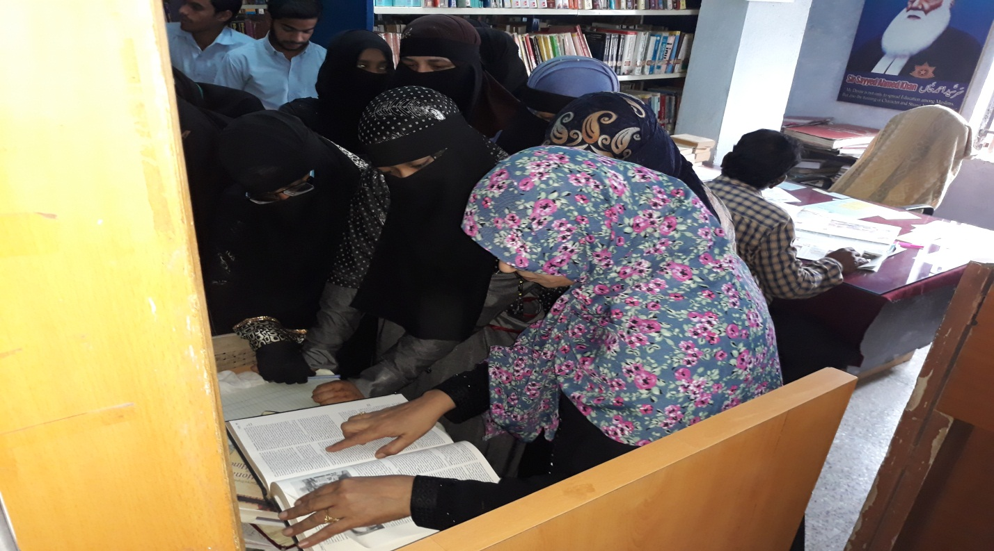

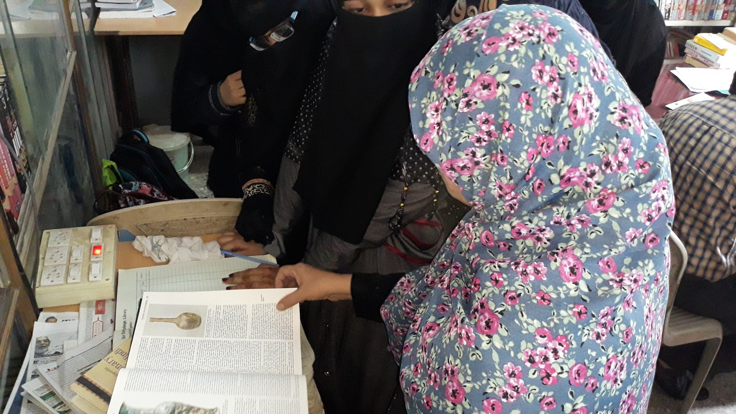

Students learning about Encyclopedia, Britanica

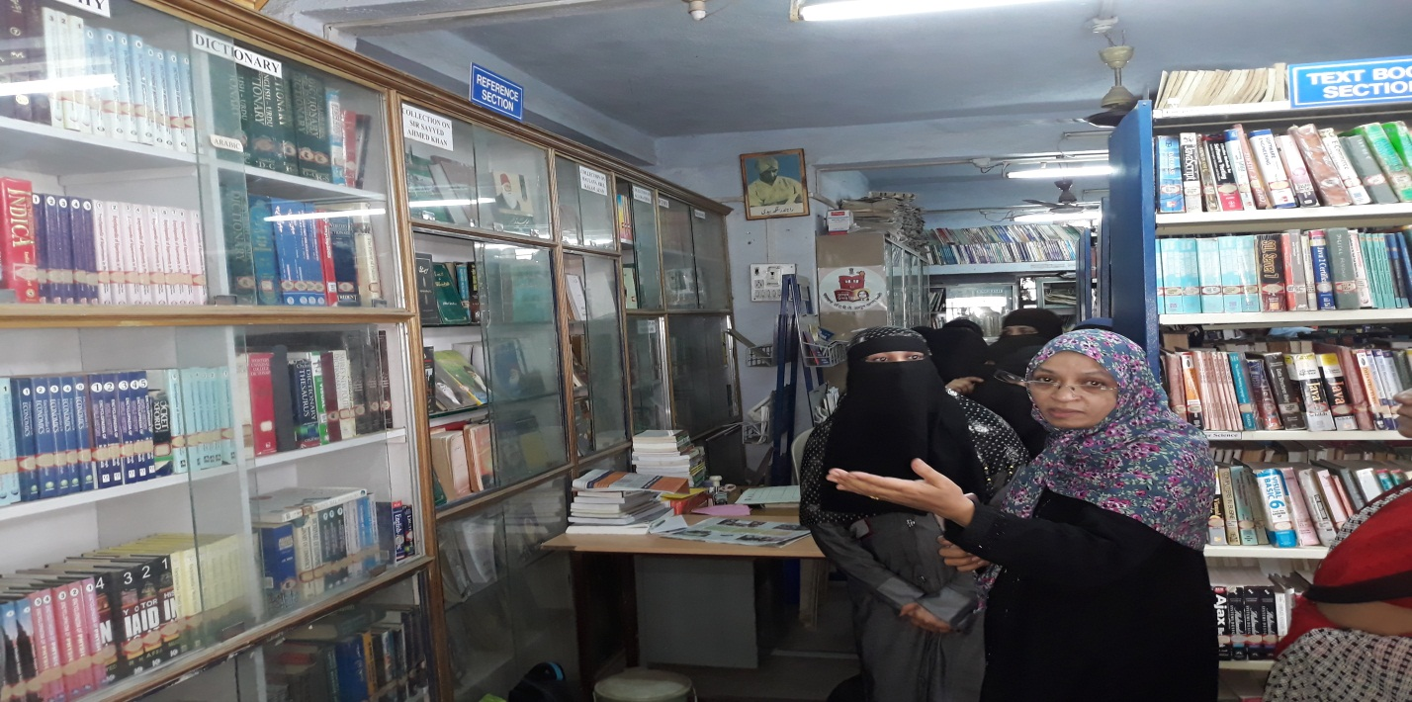

Visit of students to the Reference Section

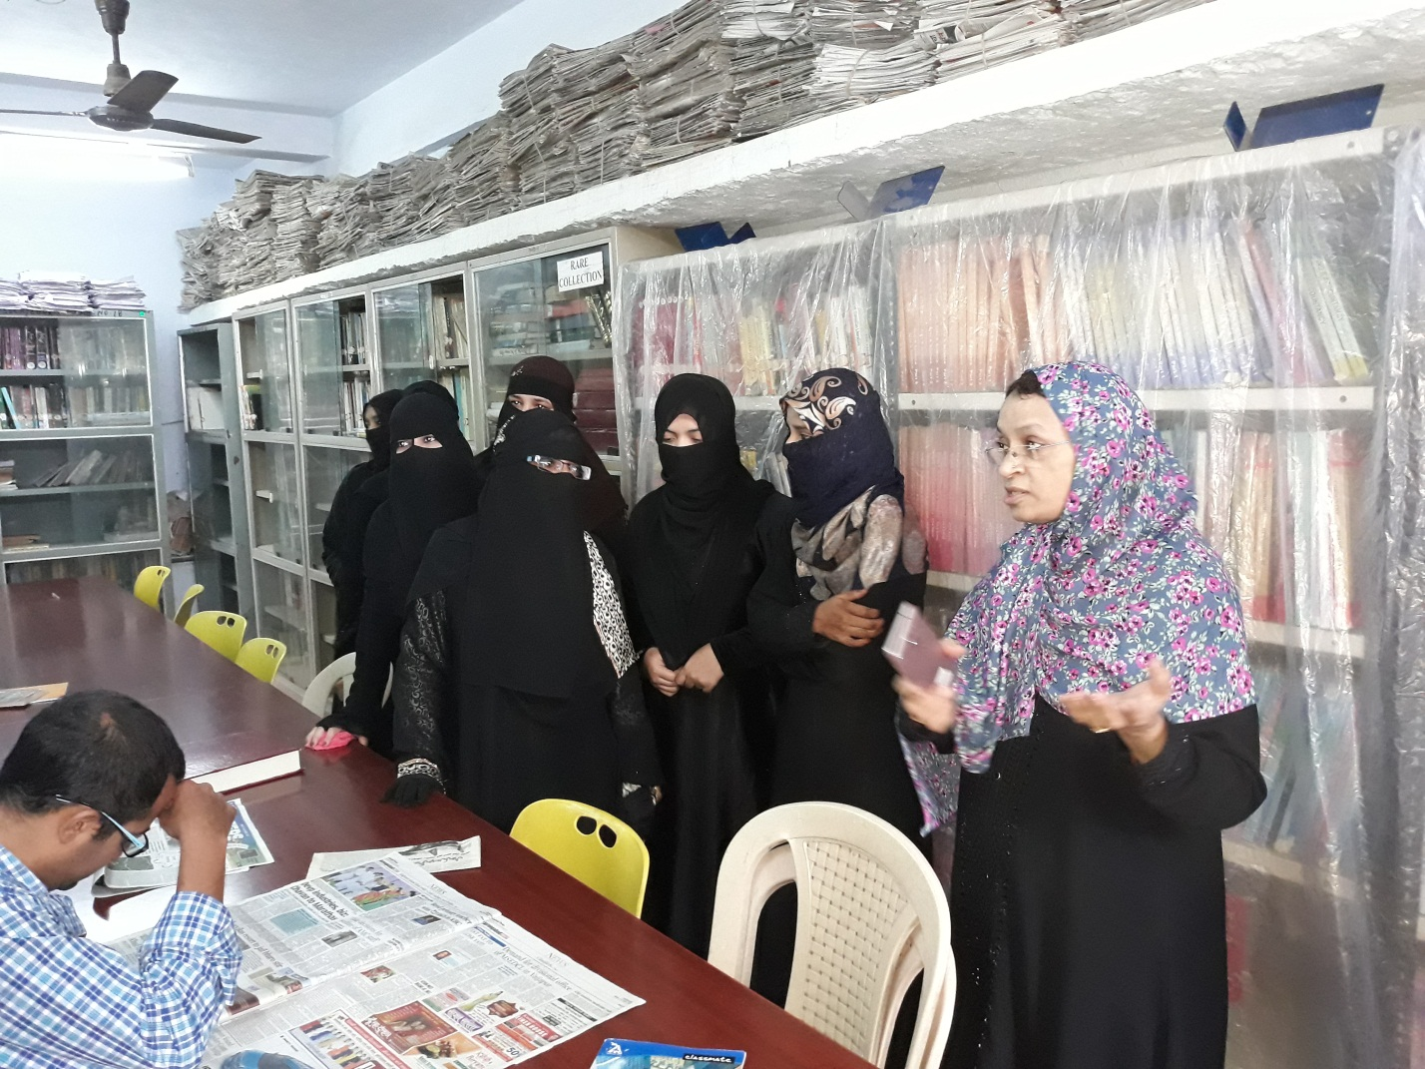

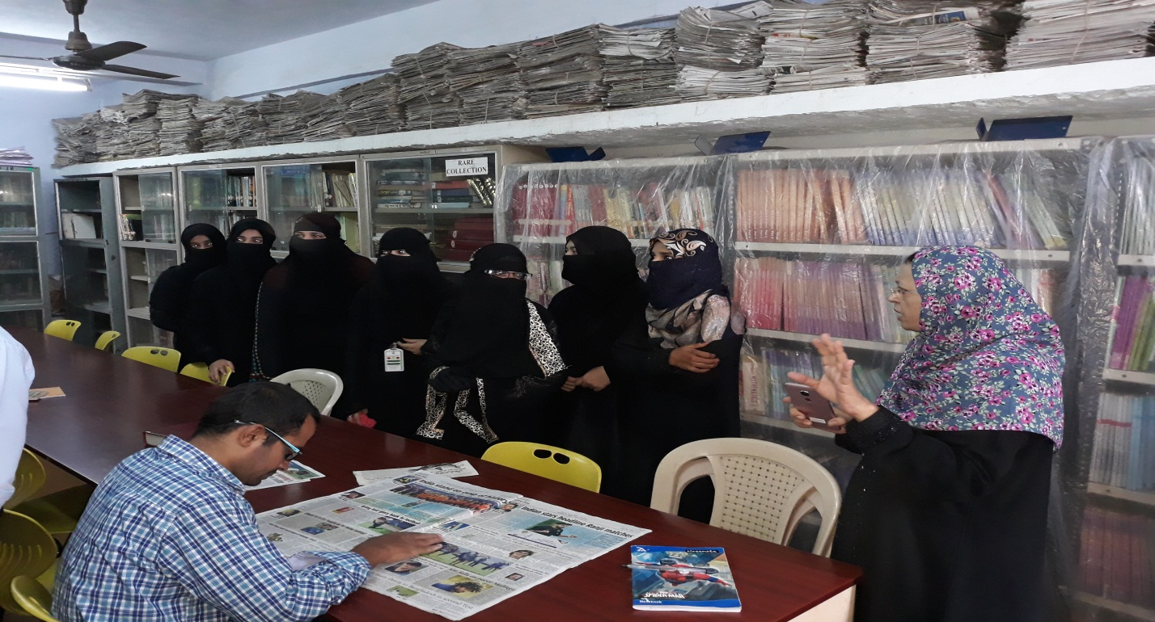

Students seethe original version of Alhilal and Albalag, weekly journal published by Maulana

Abul Kalam Azad

